## **Accessing Your WP-Config.php File**

If you are doing something where you need the name of your database, then I’m assuming you have access to your server.

Simply go to the main folder of your WordPress install and locate the file called wp-config.php.

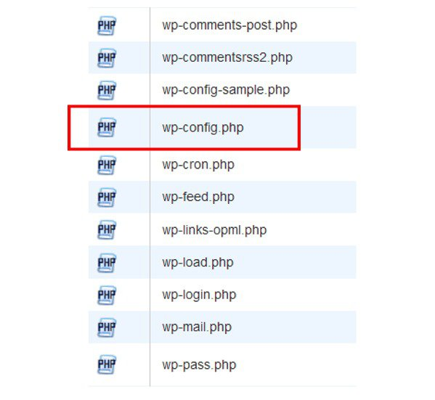

Open that file by clicking “View” or “Edit” or however your system lets you see the file.

Once your file is open, near the top after some introductory information, you should be able to spot the database name pretty clearly. It should look something like this:

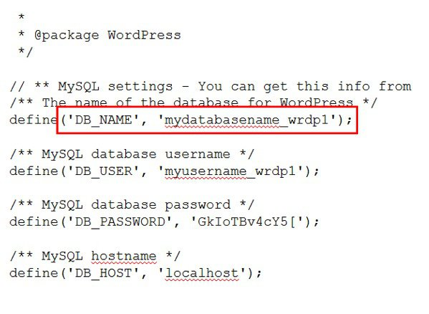

And that’s it.